Power Bi Assignment
1. Data Import:
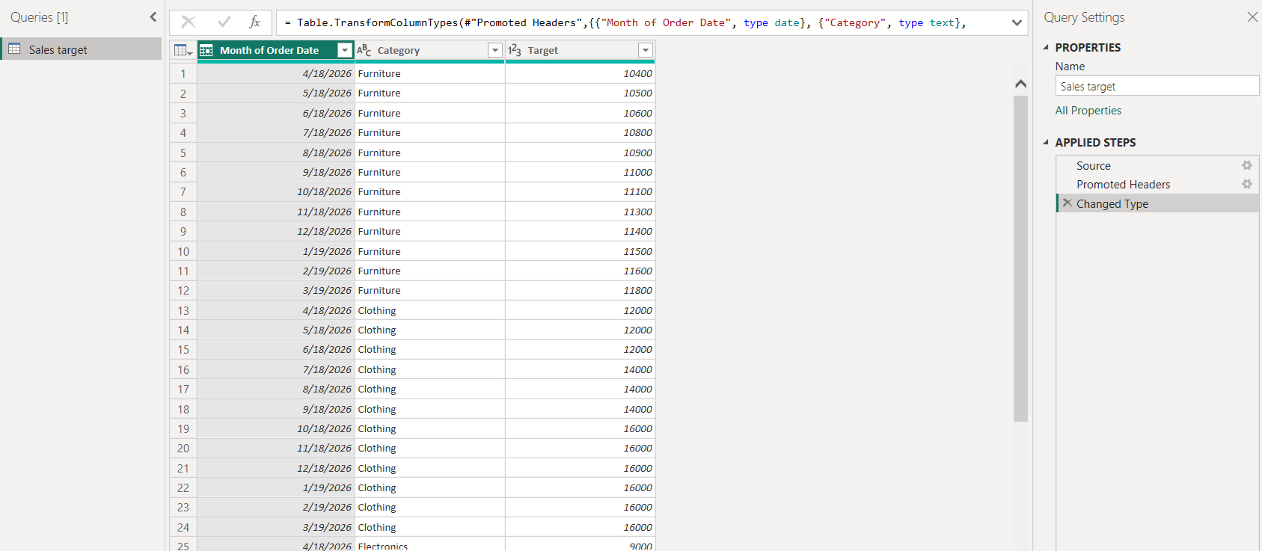
Sales Target
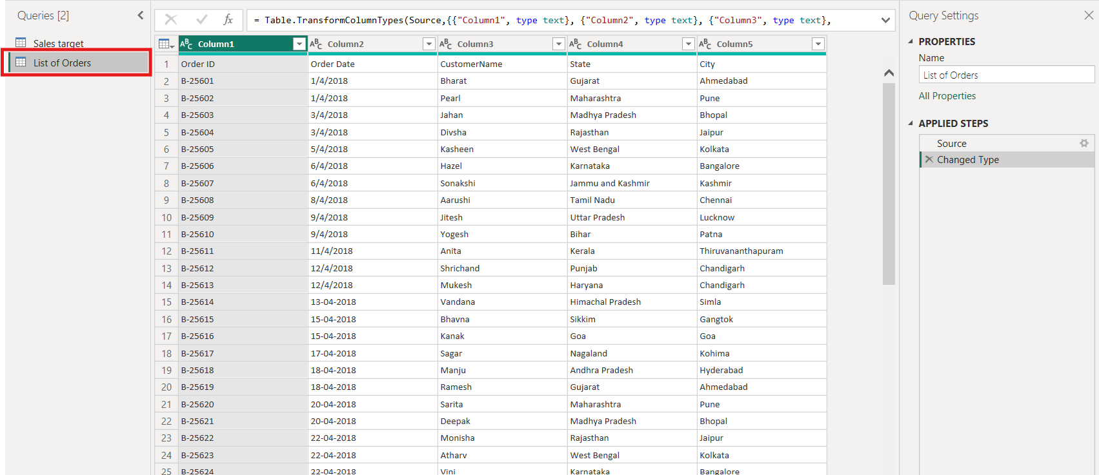
List of Orders
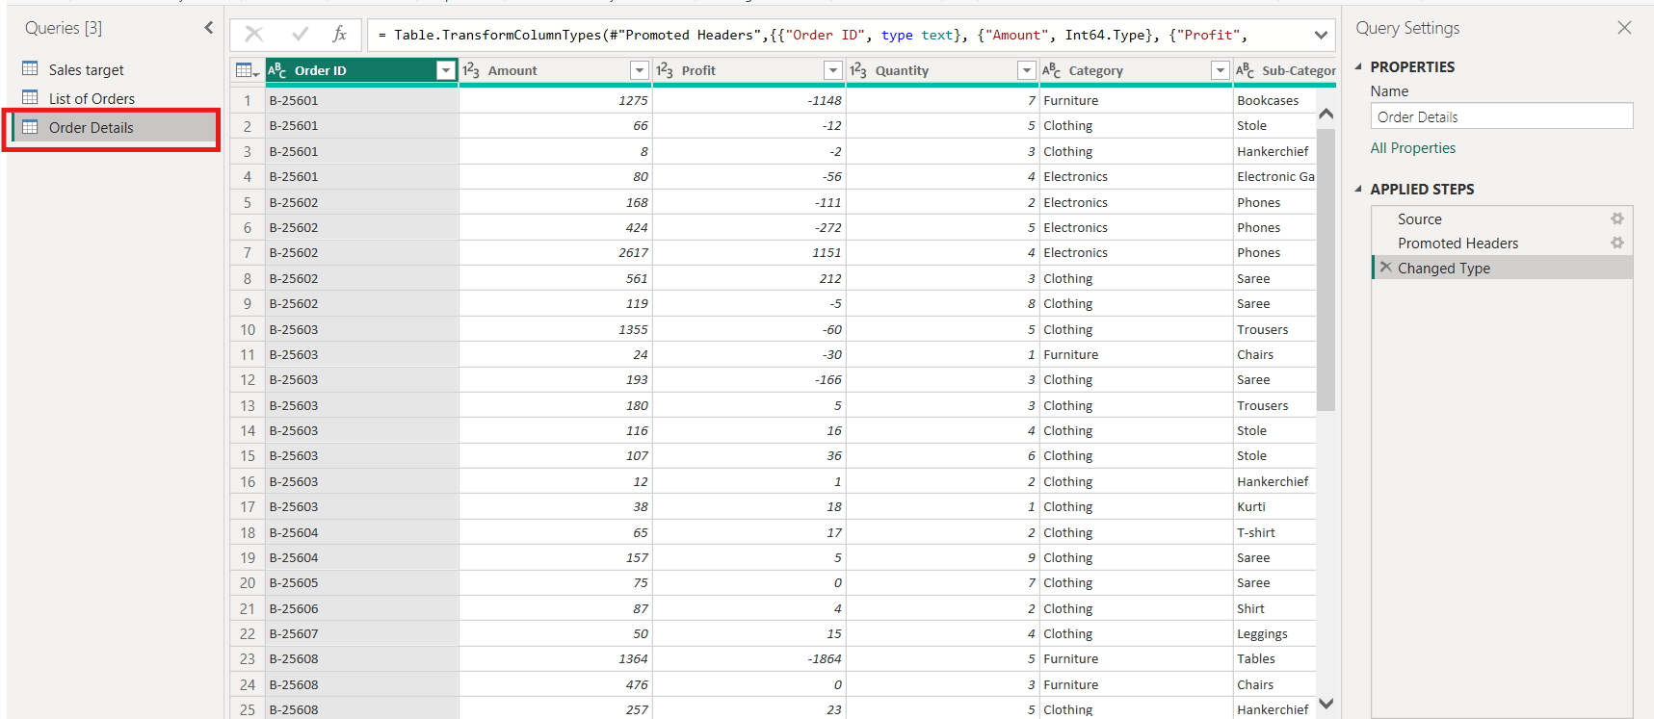
Order Details

2. Row Limiting & Data Types:
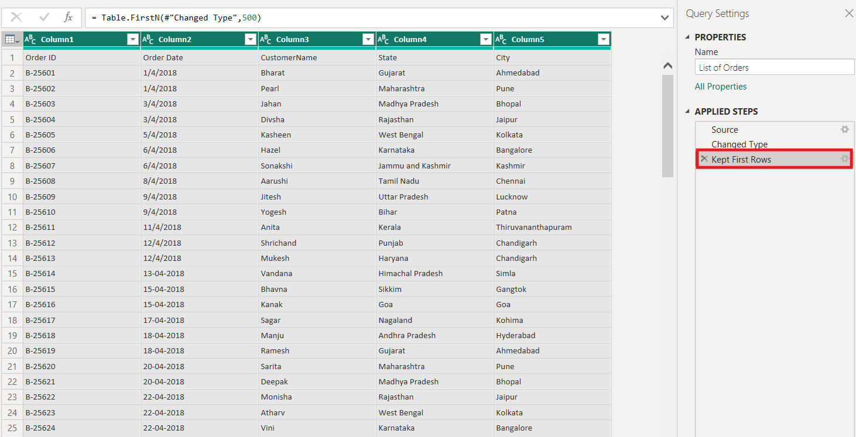
Restricted the List of Orders table to the first 500 rows
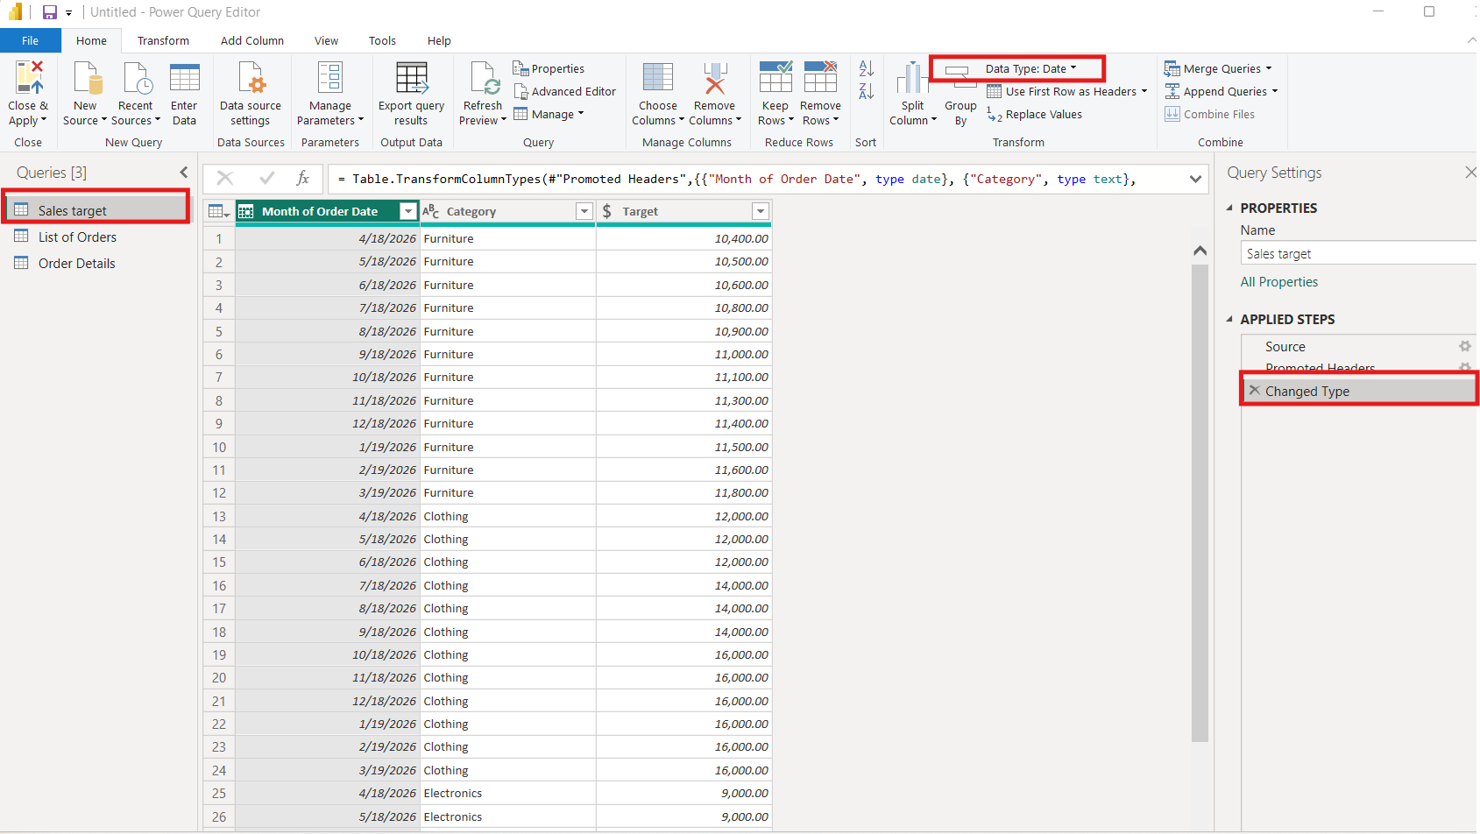
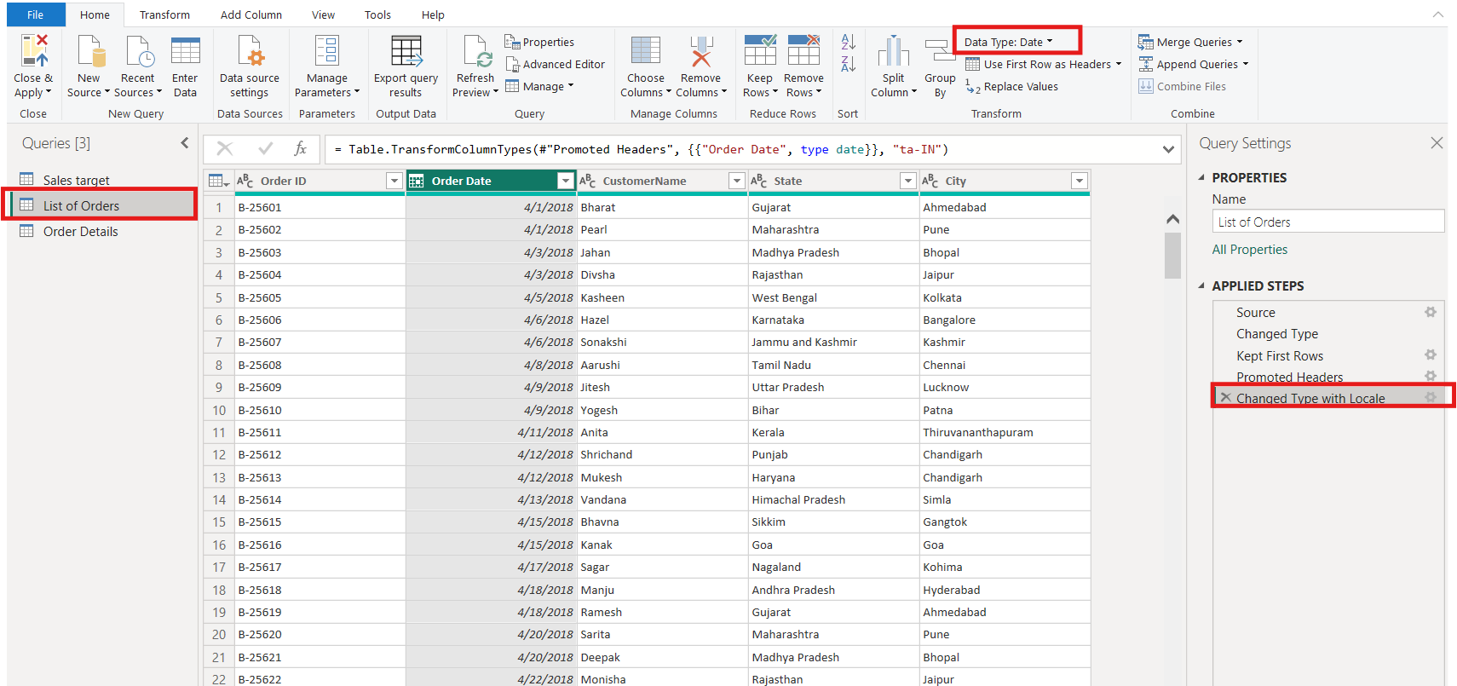
Changed Order Date column to the “Date” data type.
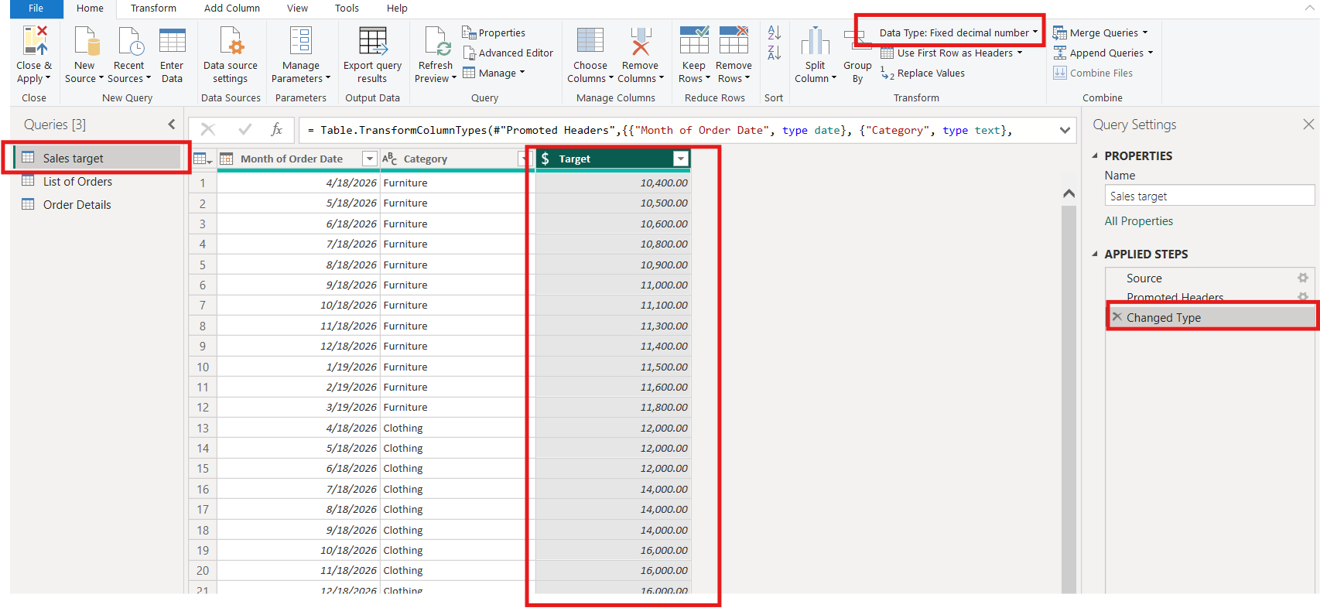
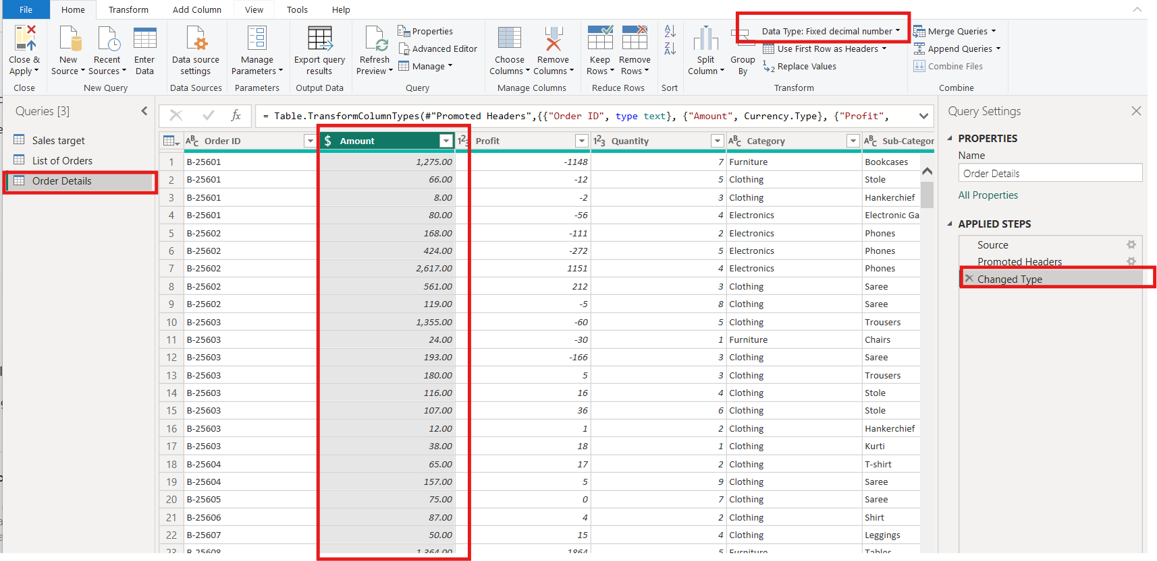
Changed the Amount and Target columns to fixed decimal numbers.

3. Text Formatting:
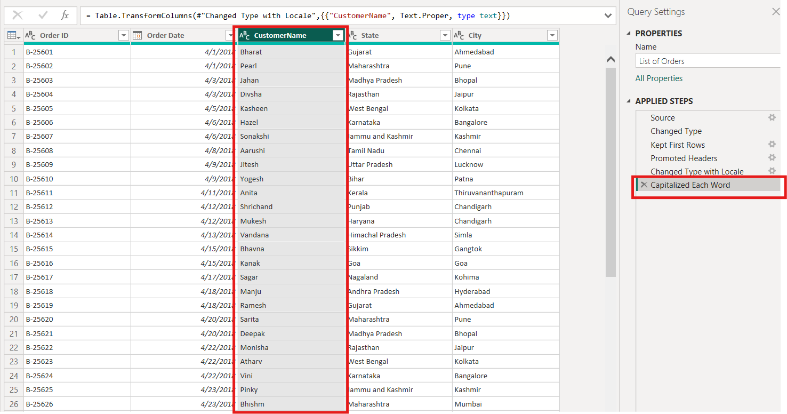
Formated the Customer Name column to proper case to ensure consistent capitalization.

4. Column Creation:
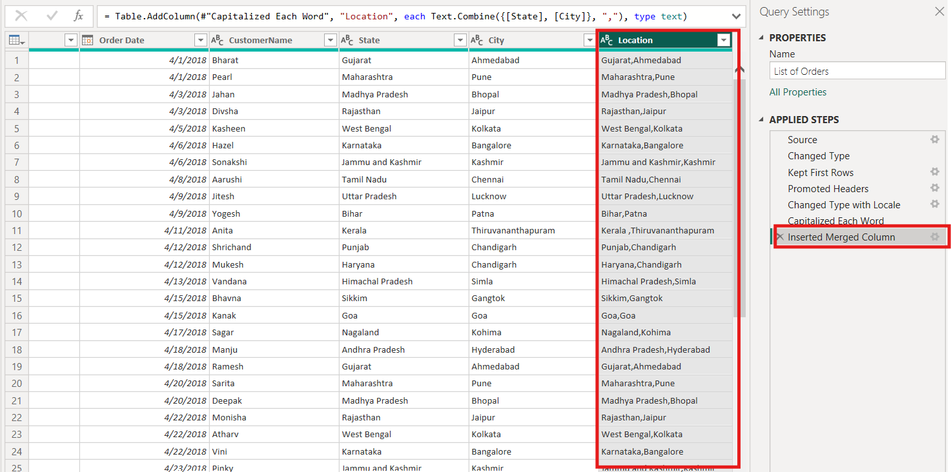
Location column Created By using “Addcolumn””Merged Column”.
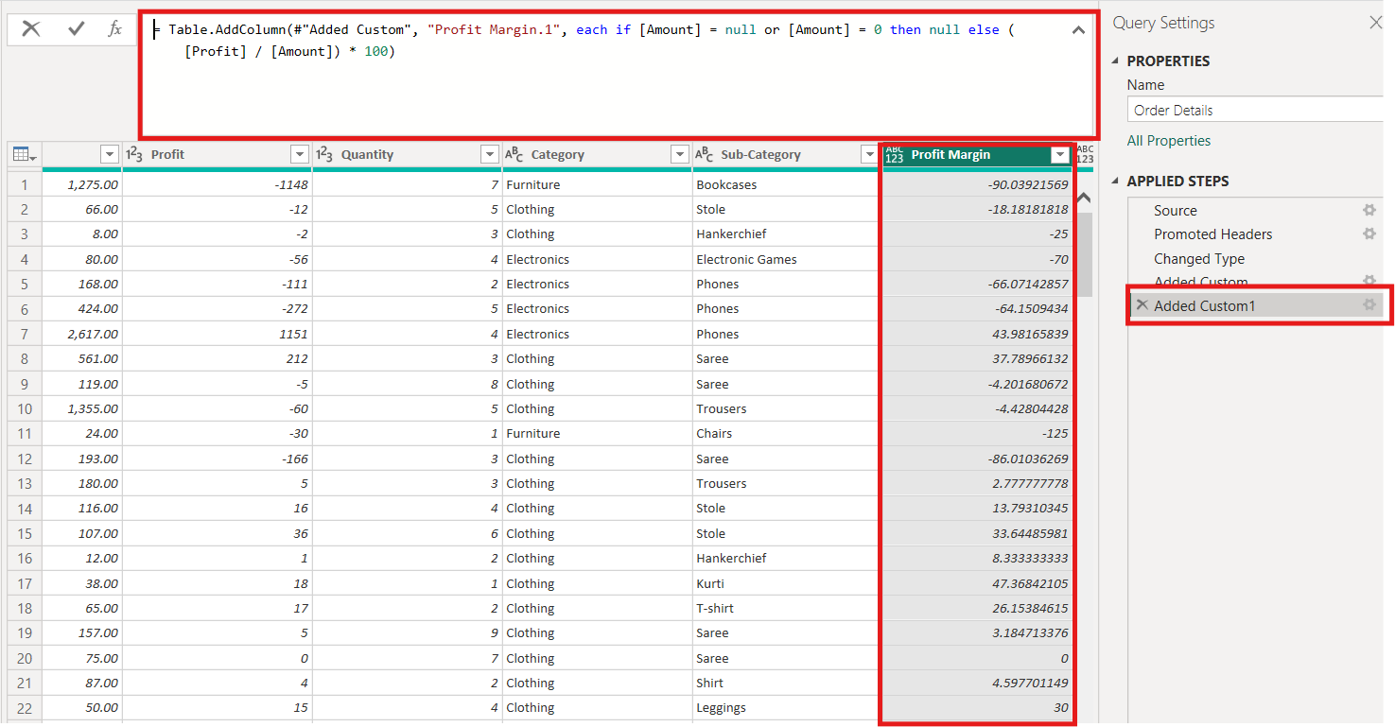
Profit Margin Column created by calculating Amount and Profit By sing following formula “= Table.AddColumn(#"Added Custom", "Profit Margin.1", each if [Amount] = null or [Amount] = 0 then null else ([Profit] / [Amount]) * 100)”

5. Conditional Column:
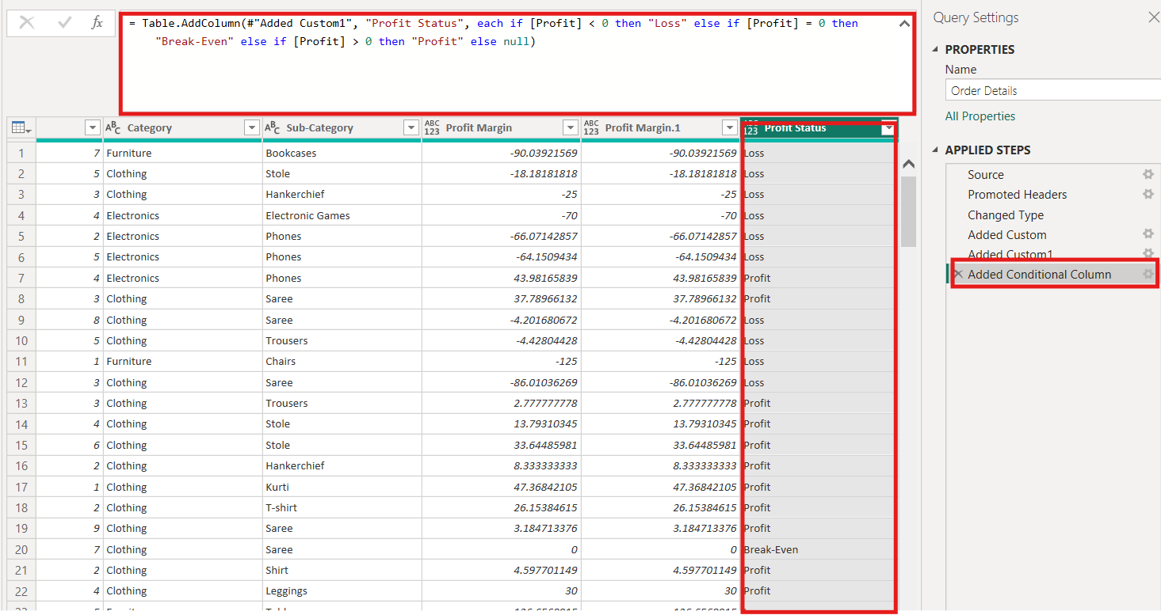
Added the Conditional Column “Add columns Conditional ColumnChanged column name to Profit status”
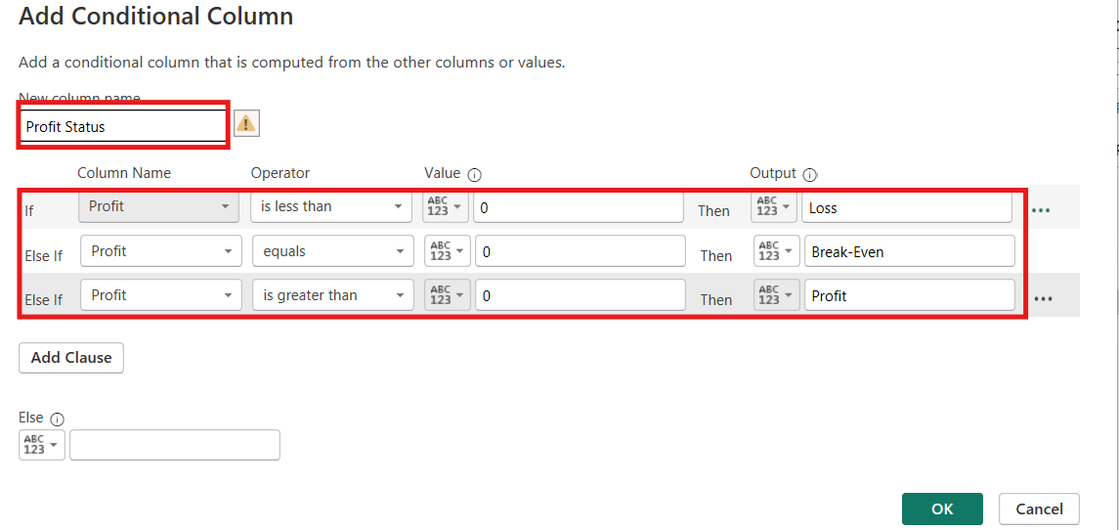
6. Merging Data (Joins):
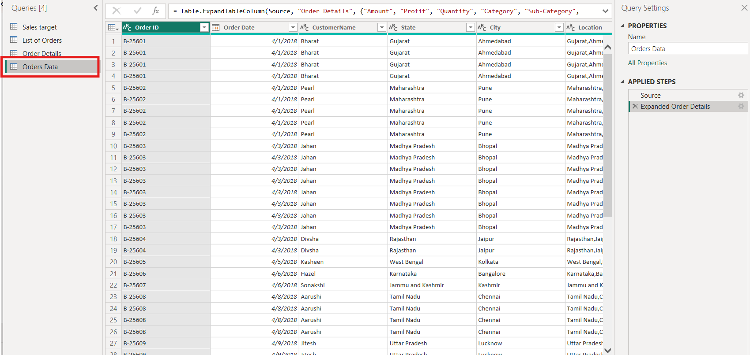
Merged the Output Table
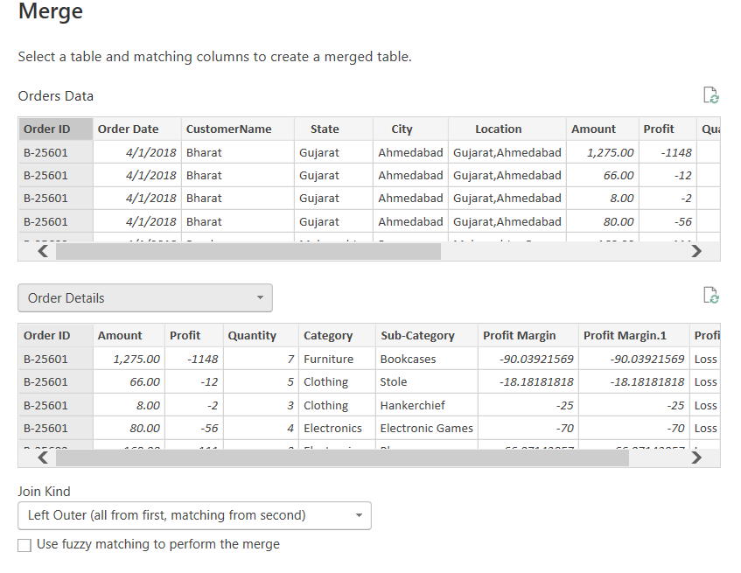
Separate Table created By using “Merged queries as a New”.
7. Handling Missing Data & Duplicate Data
Identify missing values across all tables-----There is No missing values
Define and apply appropriate strategies such as:

No blank values and missing values in Tables

Identify duplicate rows and define a suitable handling strategy based on business logic.
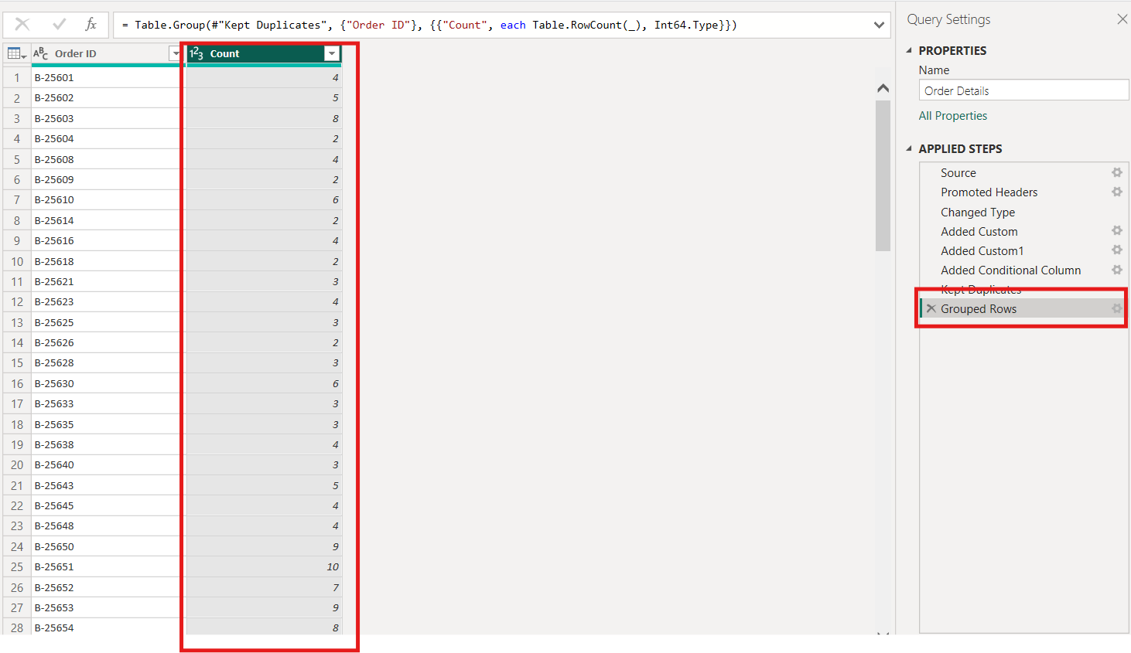
8. Sorting and Filtering Data
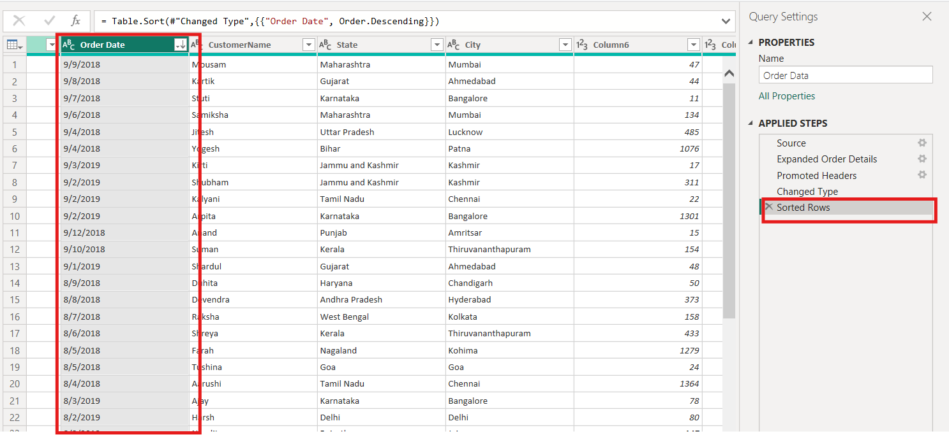
Sorted Data of Order Date column
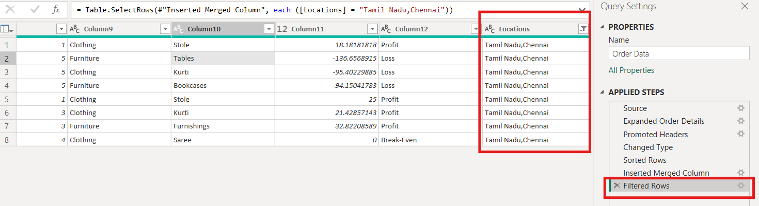
Filtered Column

9. Grouping and Aggregating Data
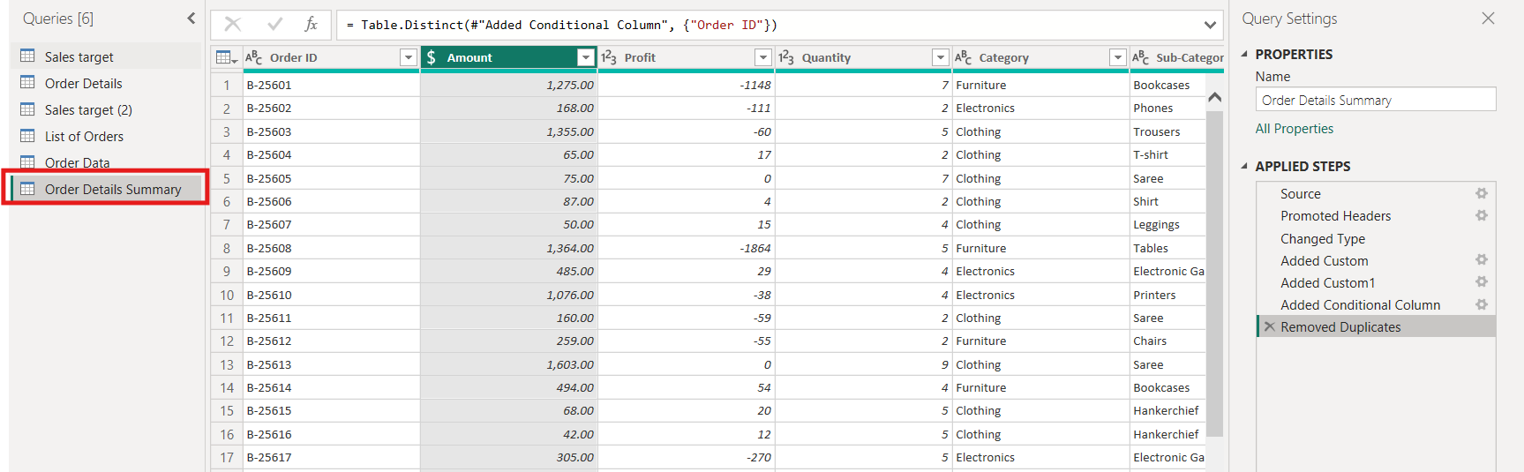
Duplicate the Order Details table
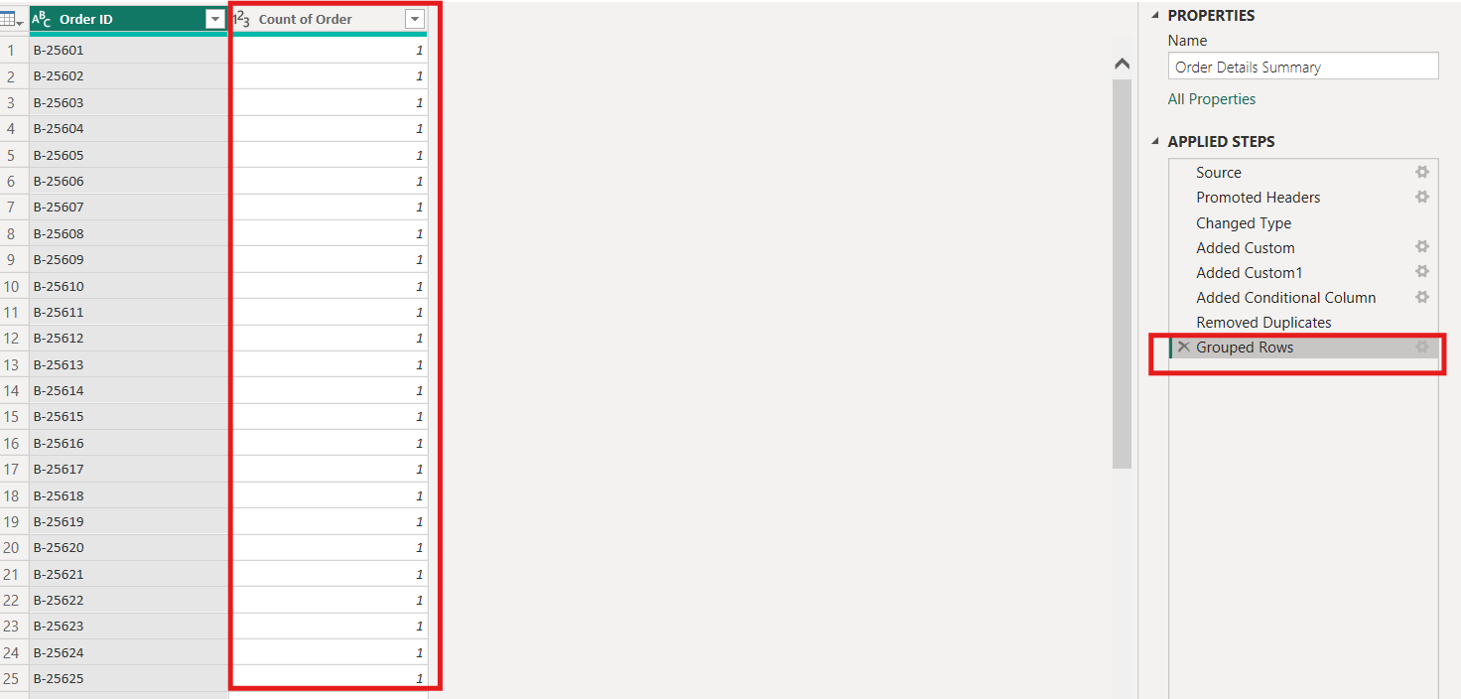
Count of Order ID
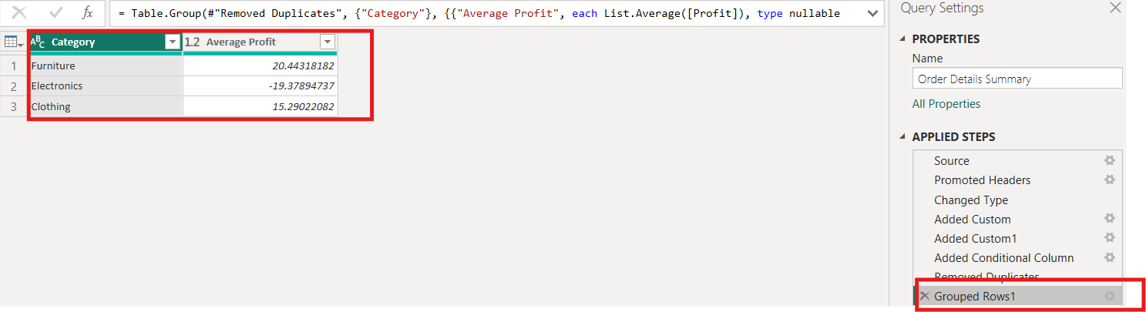
Average Profit by Category
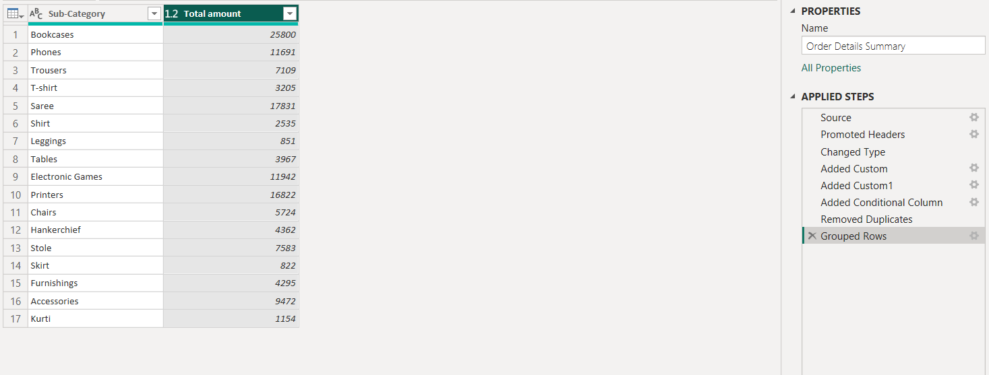
Total Amount by Sub-Category
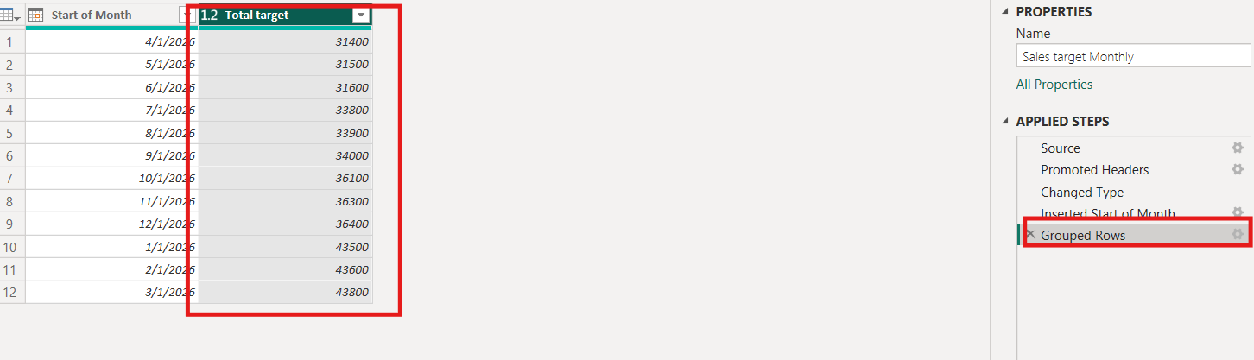
Duplicate the Sales Target table and aggregate the total Target by Month of order date.

10. Data Modeling:
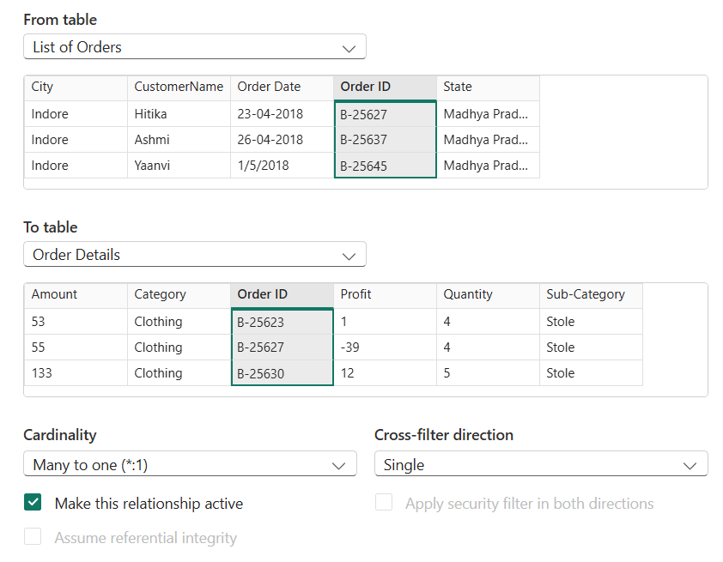
List of Orders and Order Details using Order ID
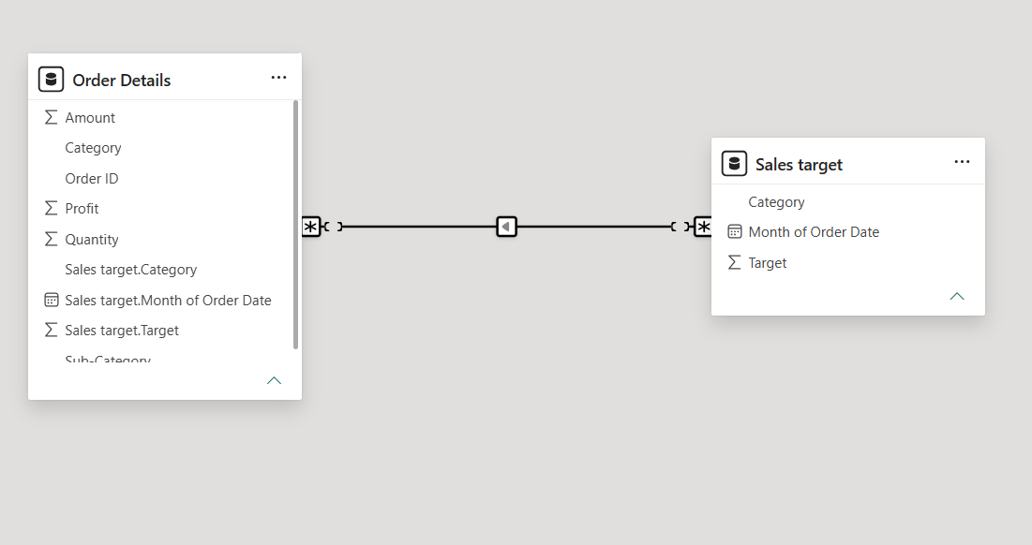
Order Details and Sales Target using Category

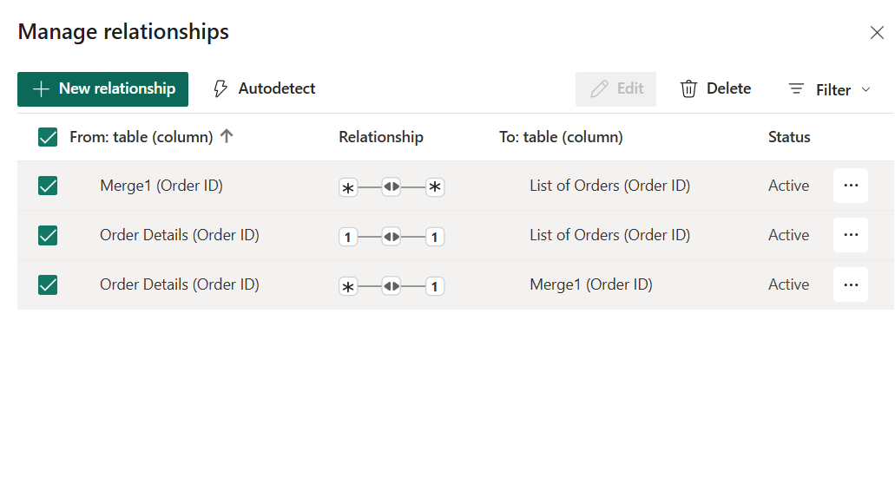
Use Manage Relationships to ensure relationships are active and correctly defined.
